Fixedlength to XML Example

1. Following fixed-length data we will parse now.

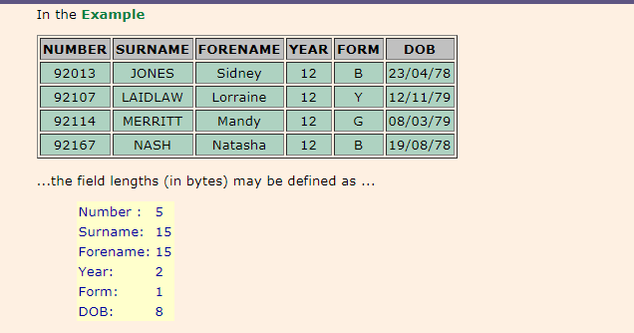

2. Click on "File" and select "New"=> "Application".

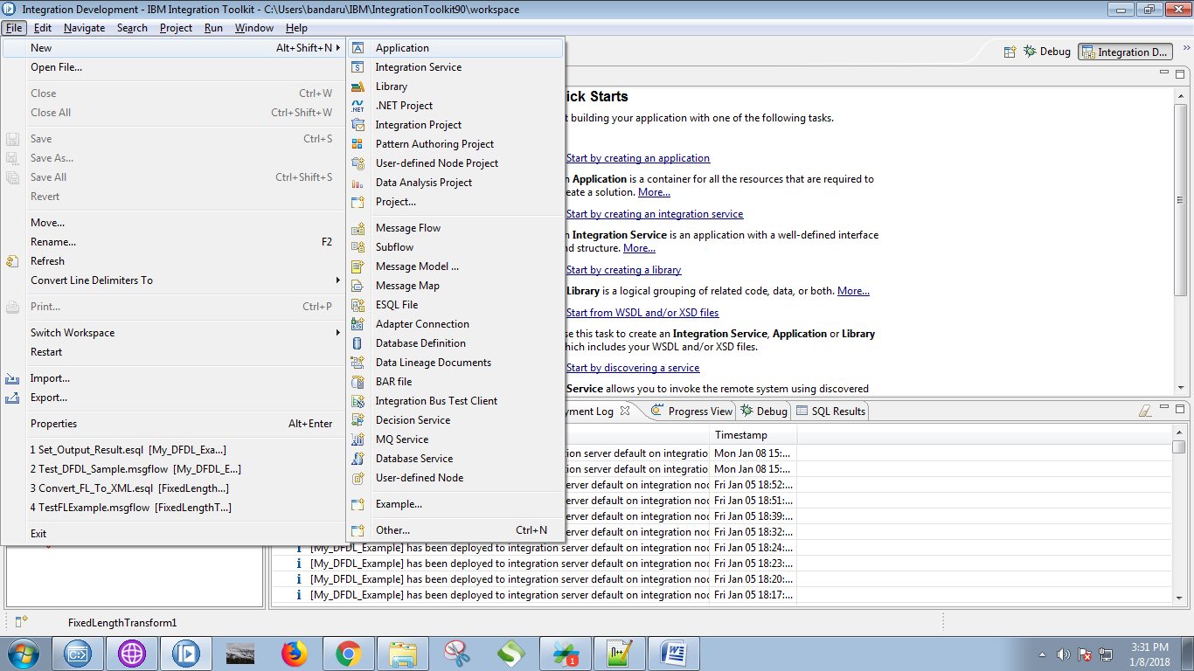

3. Give a name for your application and click on "Finish" button.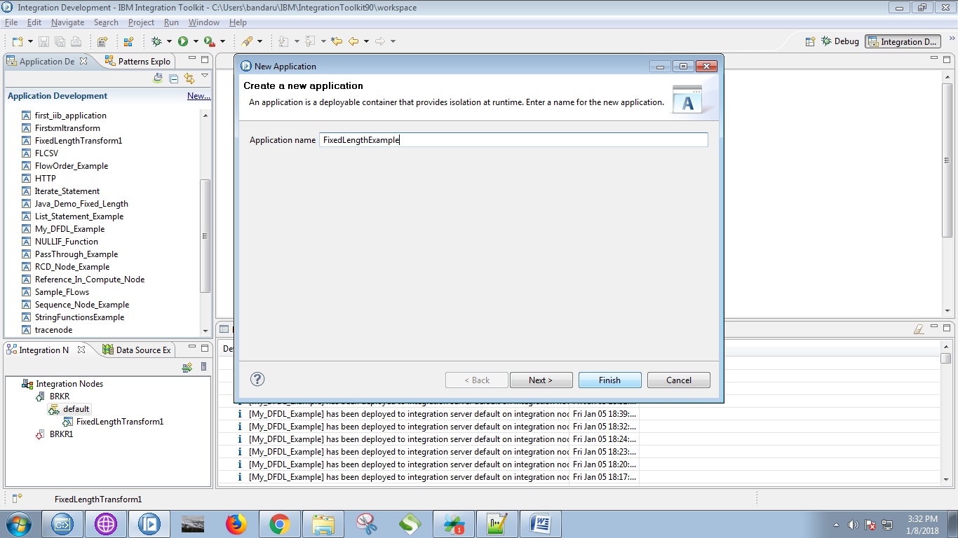

4. Now right click on application and select "New"=> "Message Model".

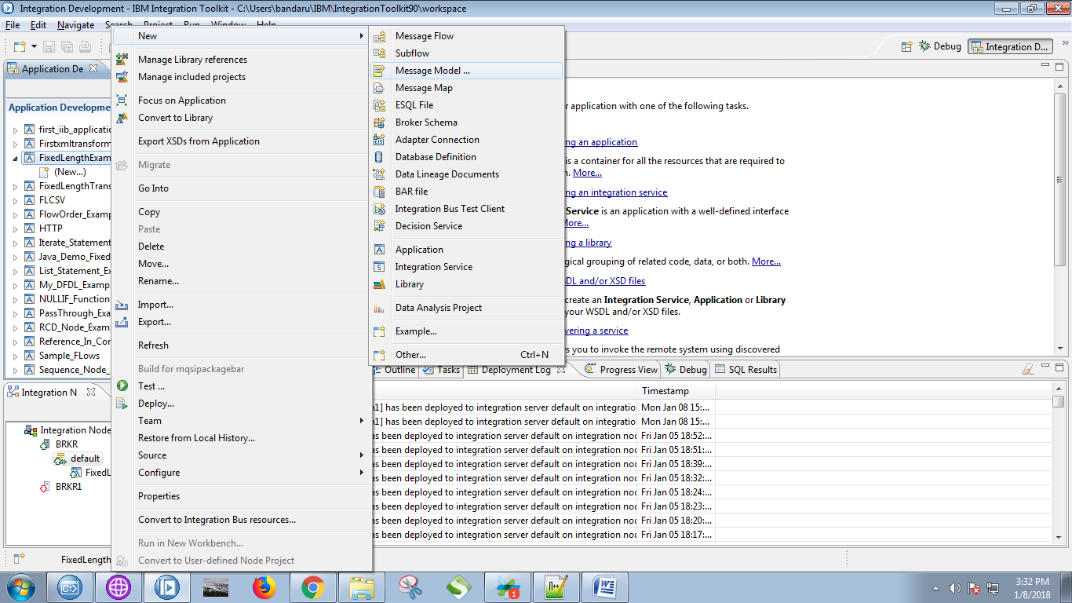

6. check "Record-oriented text" from the following fig and click on "Next" button.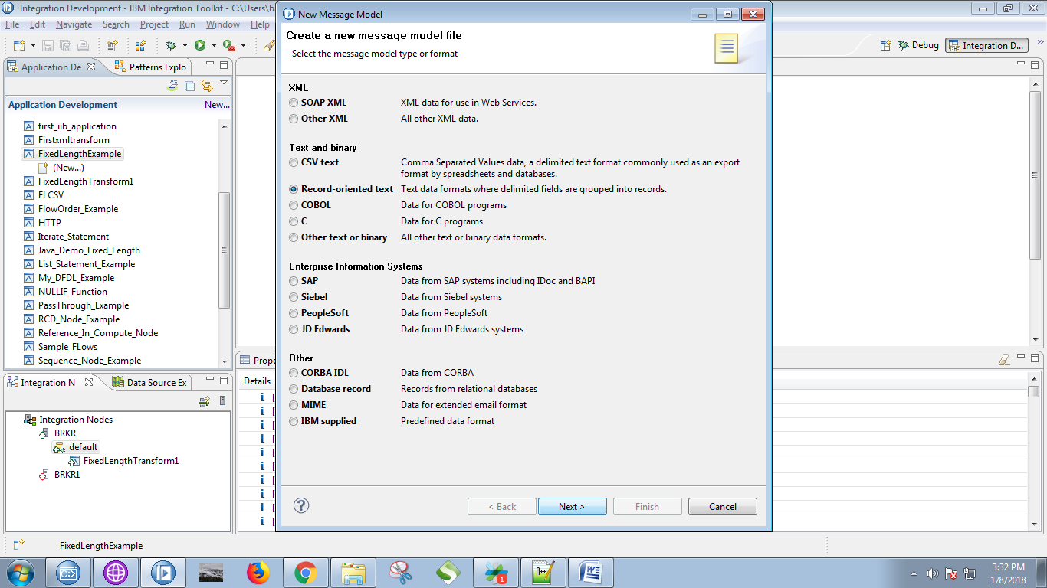

7. Check on first radio button when following screen pops up and click on "Next" button.

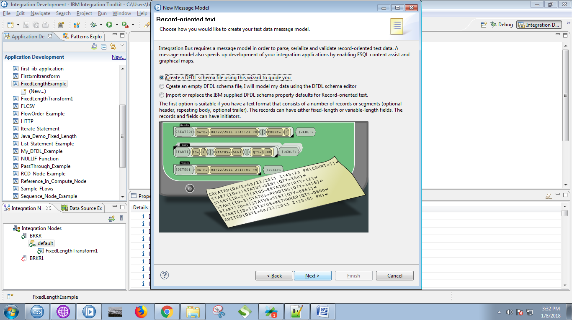

8. Give a name for your "DFDL file" as well as for "message" and click on "Next" button.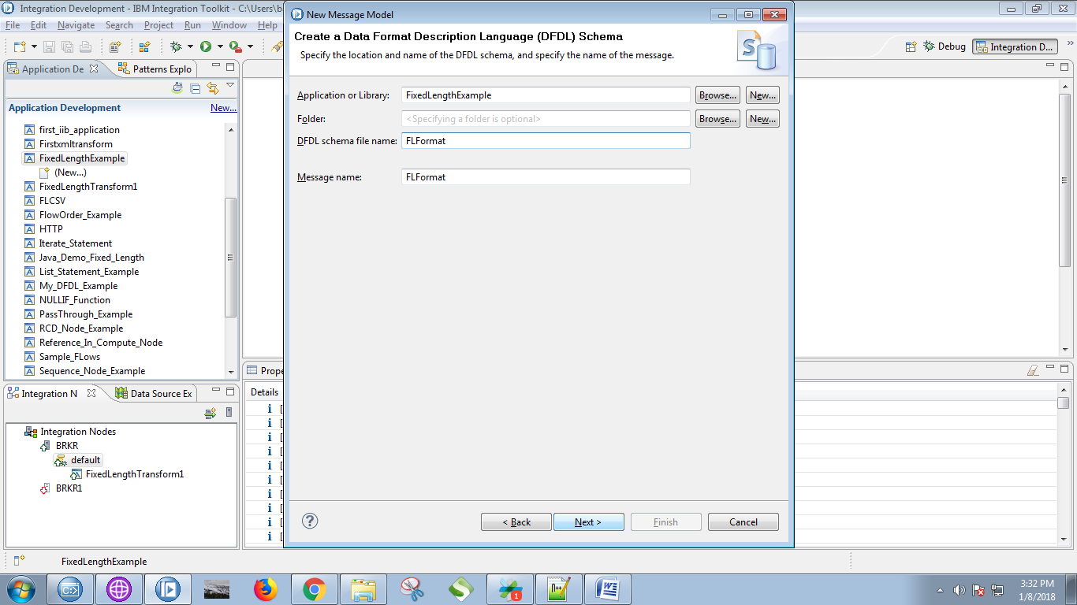

9. please follow the yellow marked steps.

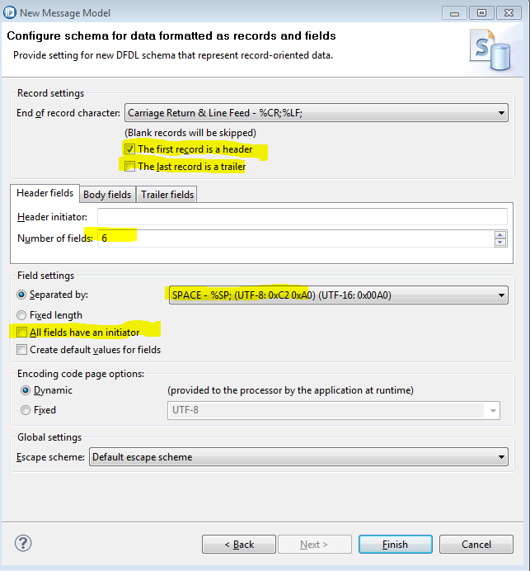

10. Also set body fields and click on "Finish" button.

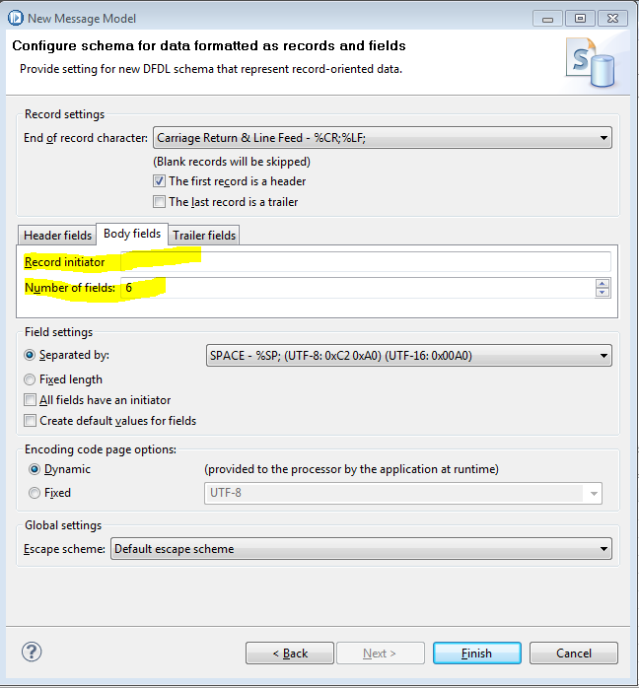

11. Following screen will appears.

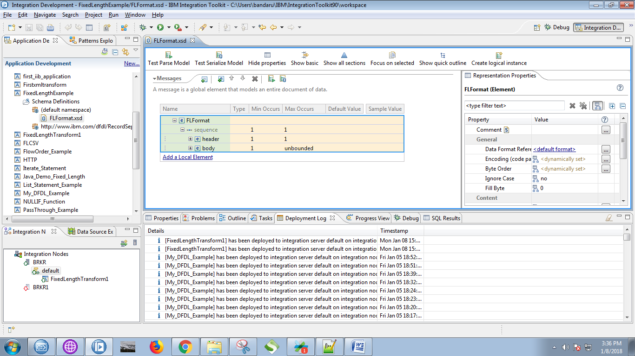

12. Give a names for your headers and set "length" and "pad kind" properties values for them. 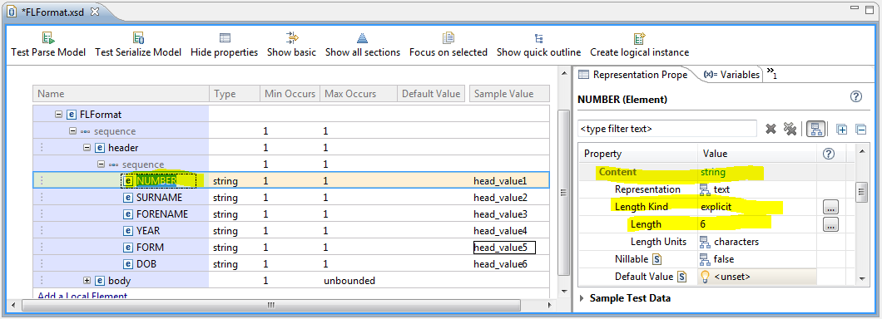

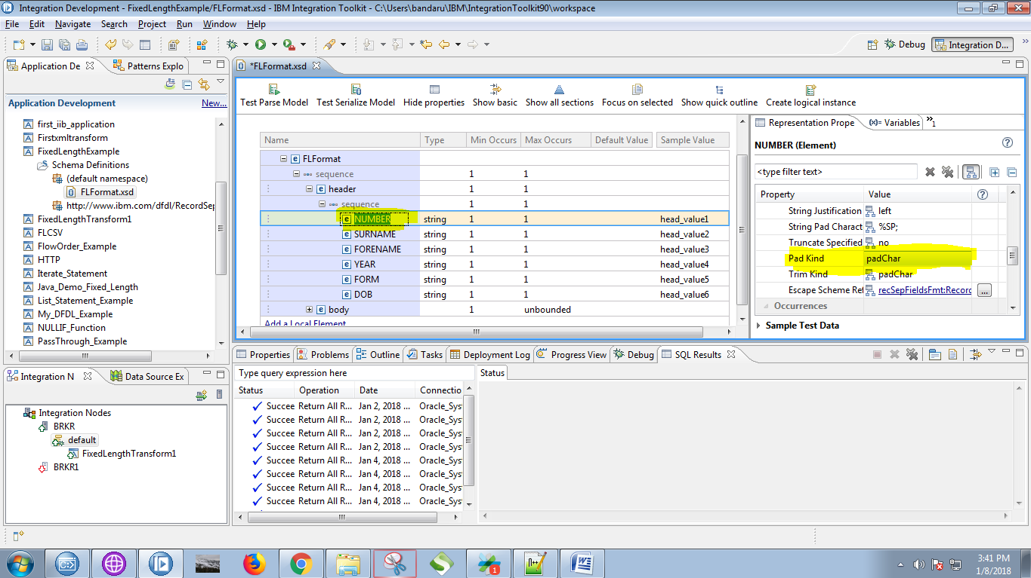

similarly set length (14,14,5,5,8) for headers(surname, forename, year, form, DOB) respectively

and also set "Pad Kind" value to "padChar" for each headers.

13. Also set "length" property values for body fields.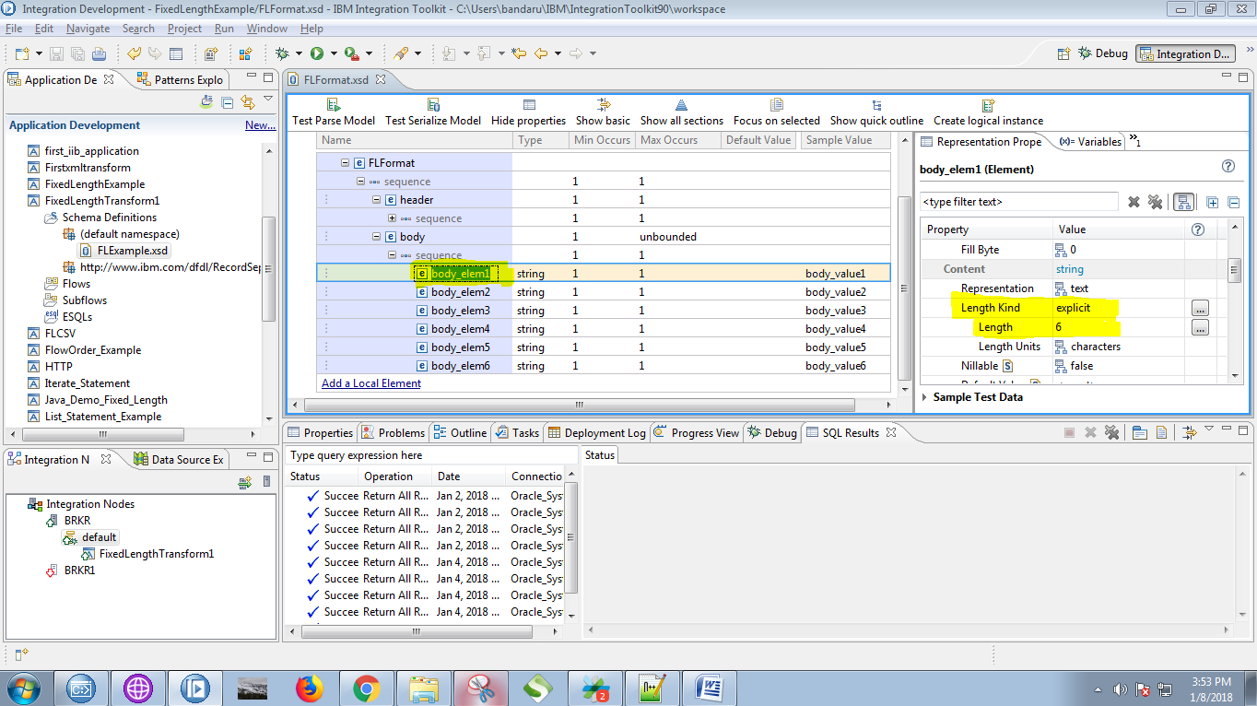

similarly set length (14,14,5,5,8) for body(body_ele2, body_ele3, body_ele4, body_ele5, body_ele6) respectively.

14. Click on "Test Parse Model"

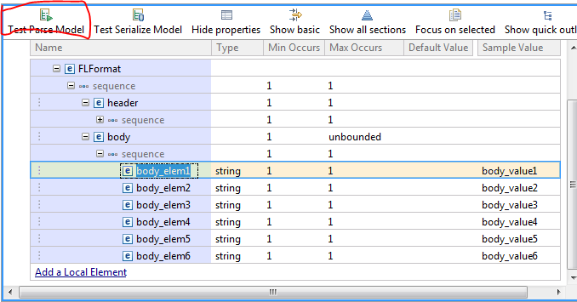

15. Click on "Browse" button.

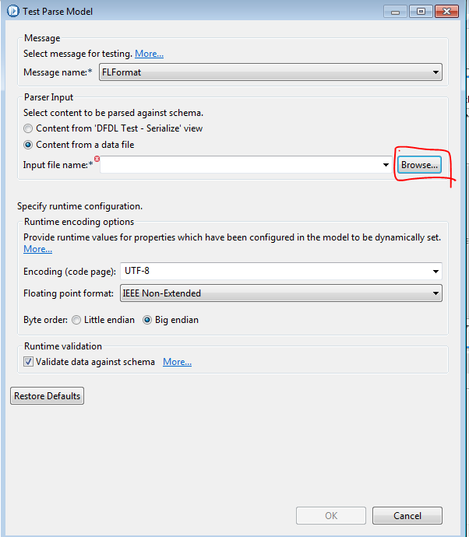

16. Select the check box value and click on "Browse" button.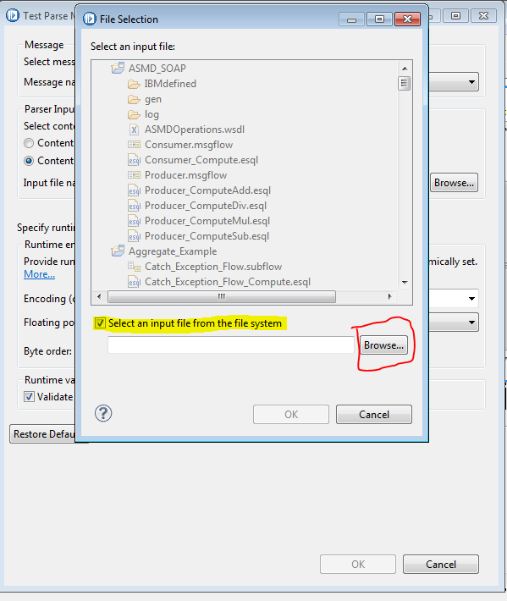

17. Give your fixed length format example file and click on "OK" button.

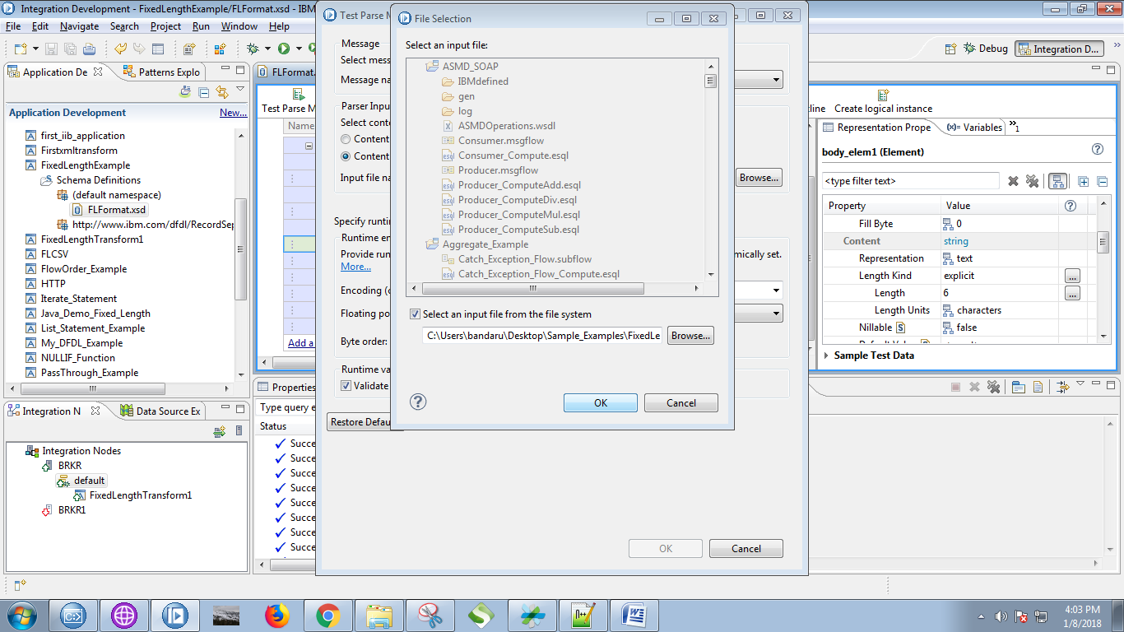

18. successful parse screen will follows as below.

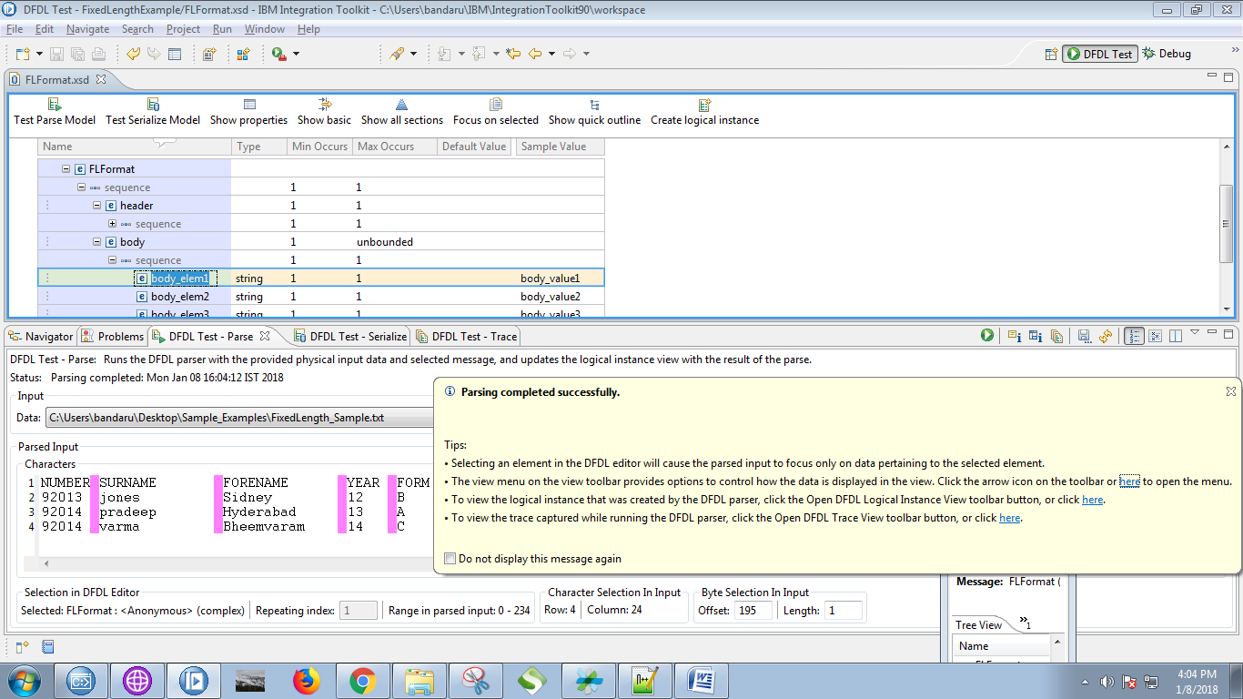

19. Right click on your application and select "New"=> "Message Flow".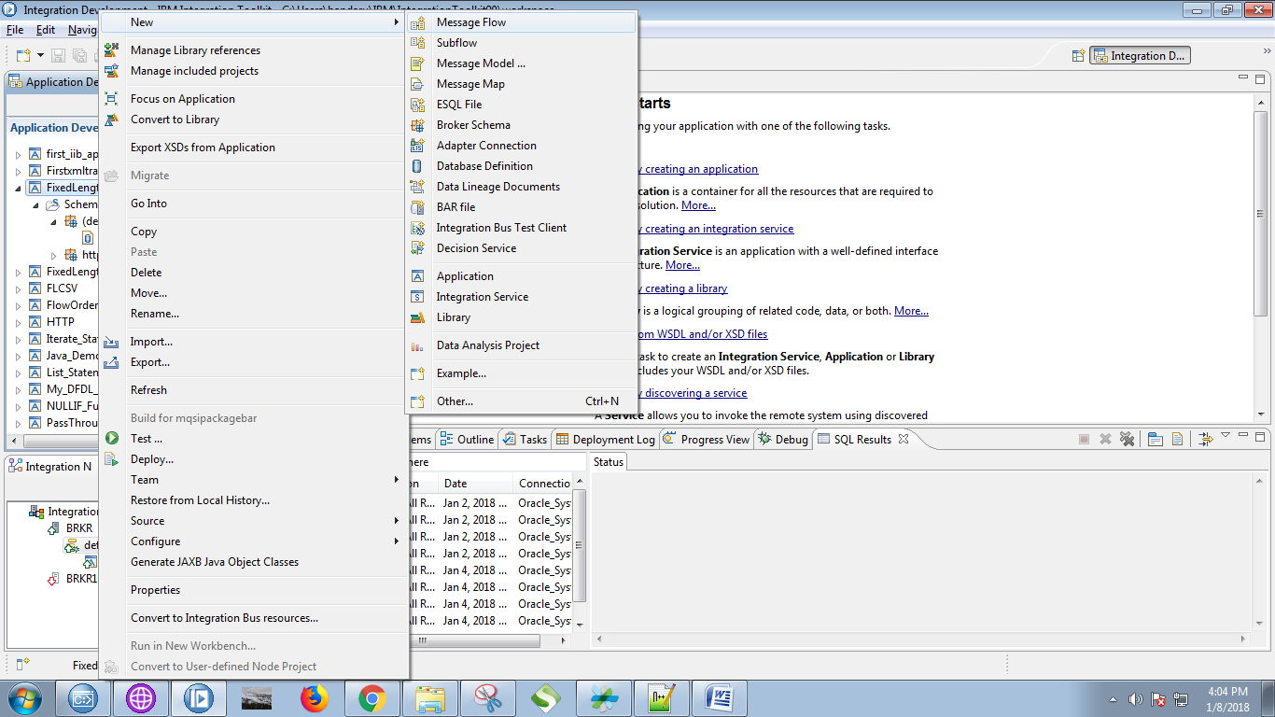

20. Give a name for your flow and click on "Finish" button.

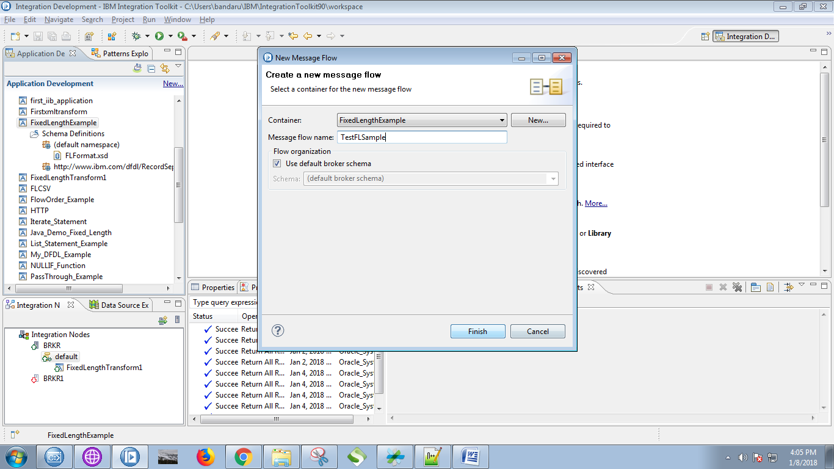

21. Drag the MQInput from the "WebSphere MQ" section and name it, as shown in below fig.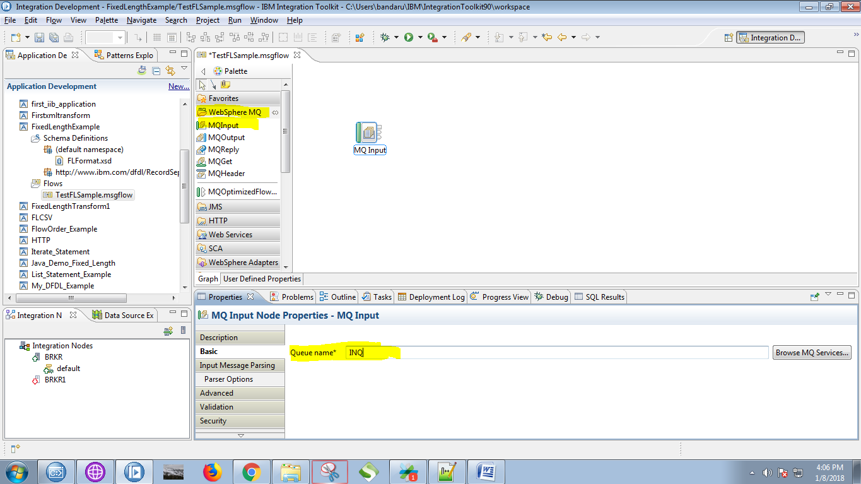

22. Select "DFDL" as Message domain and click on "Browse" button.

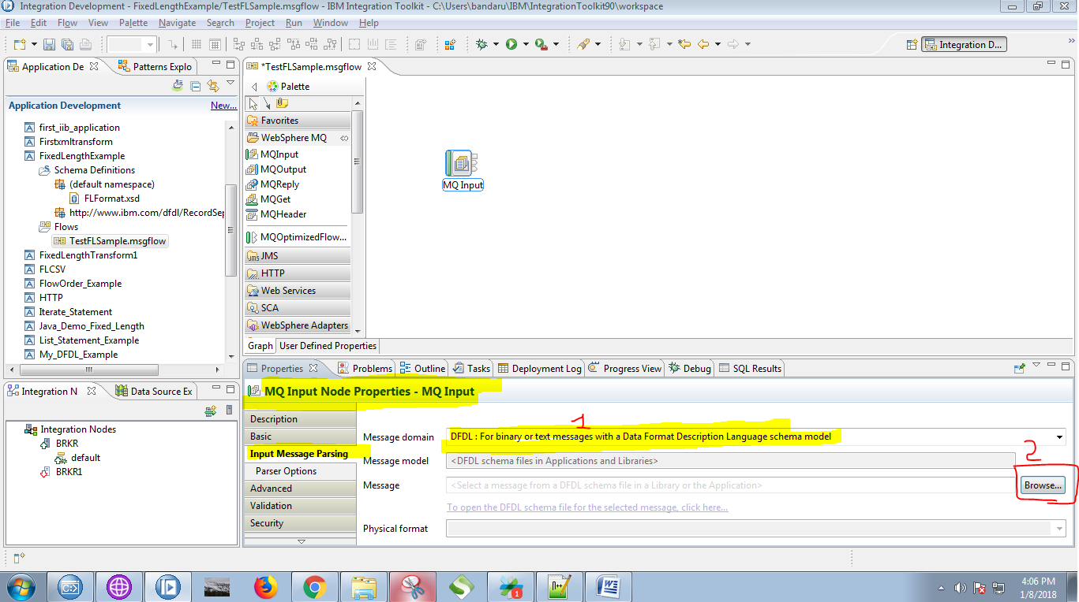

23. Select your fixed length message model and click on "OK" button.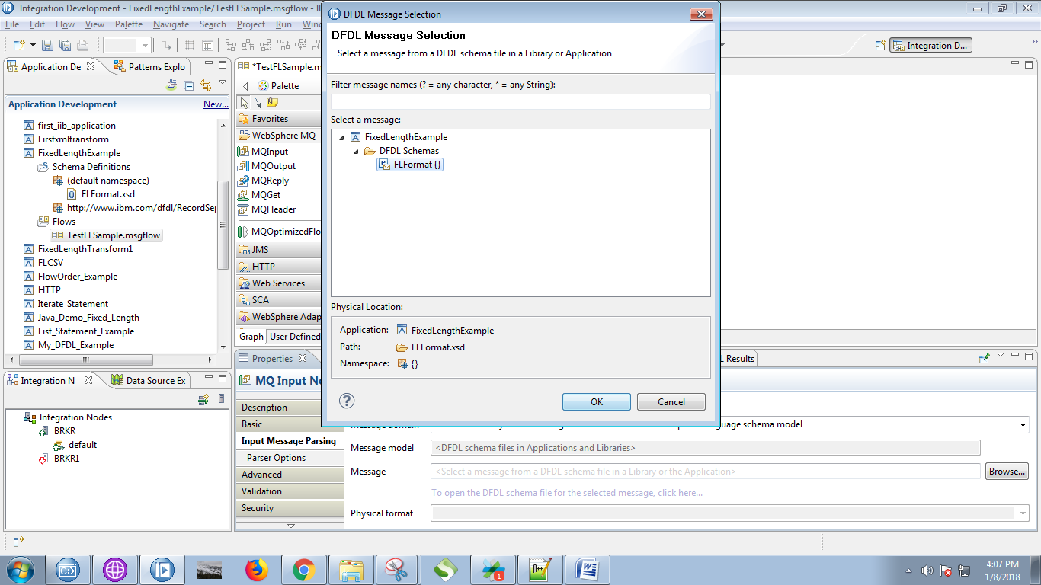

24. Drag the "compute" node from the "Transform" section.

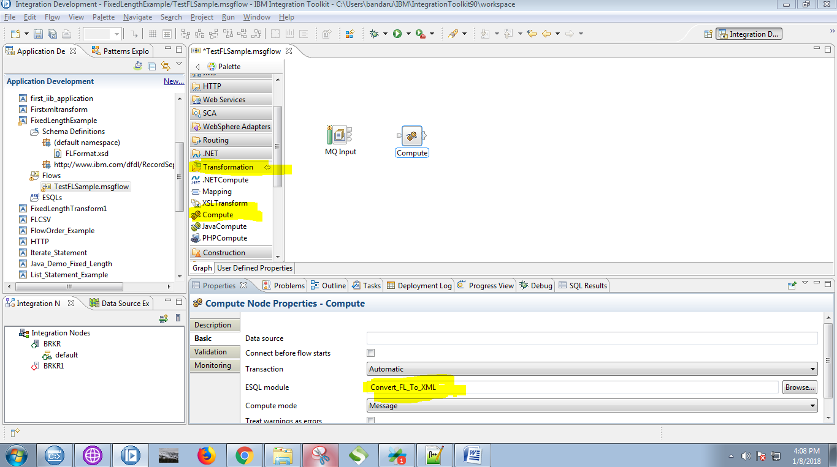

25. Connect "output" terminal of the MQInput with the "input" terminal of the compute node.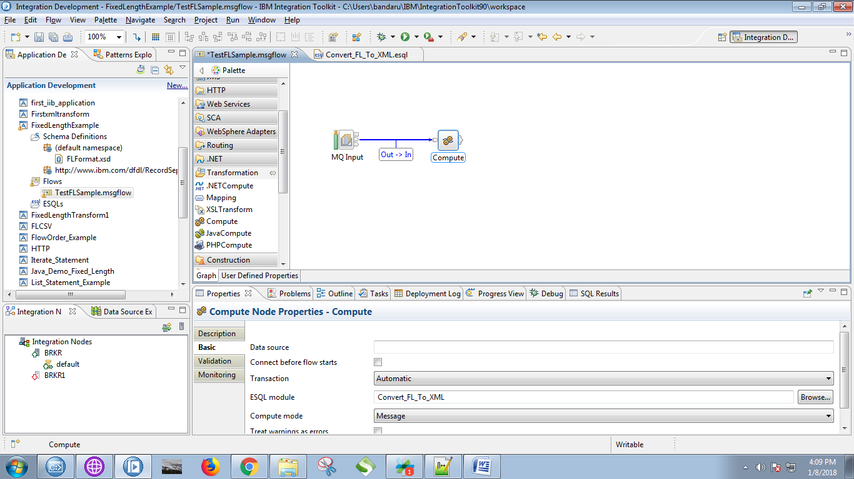

26. Drag the MQOutput from the "WebSphere MQ" and give it a name.

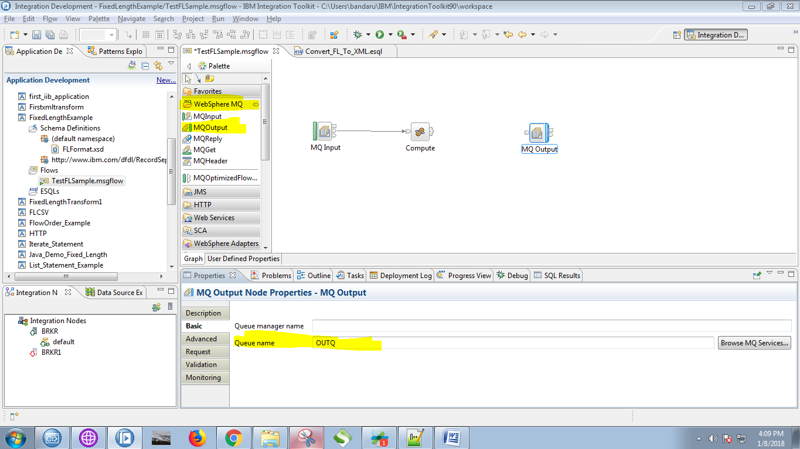

27. Click on output terminals of the compute node and select "Out" and click on "OK" button.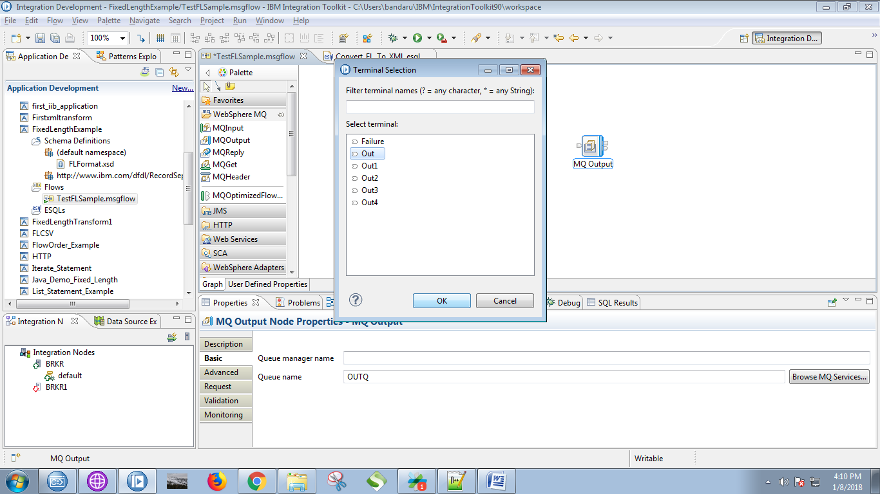

28. Connect "output" terminal of the compute node with "input" terminal of the MQOutput.

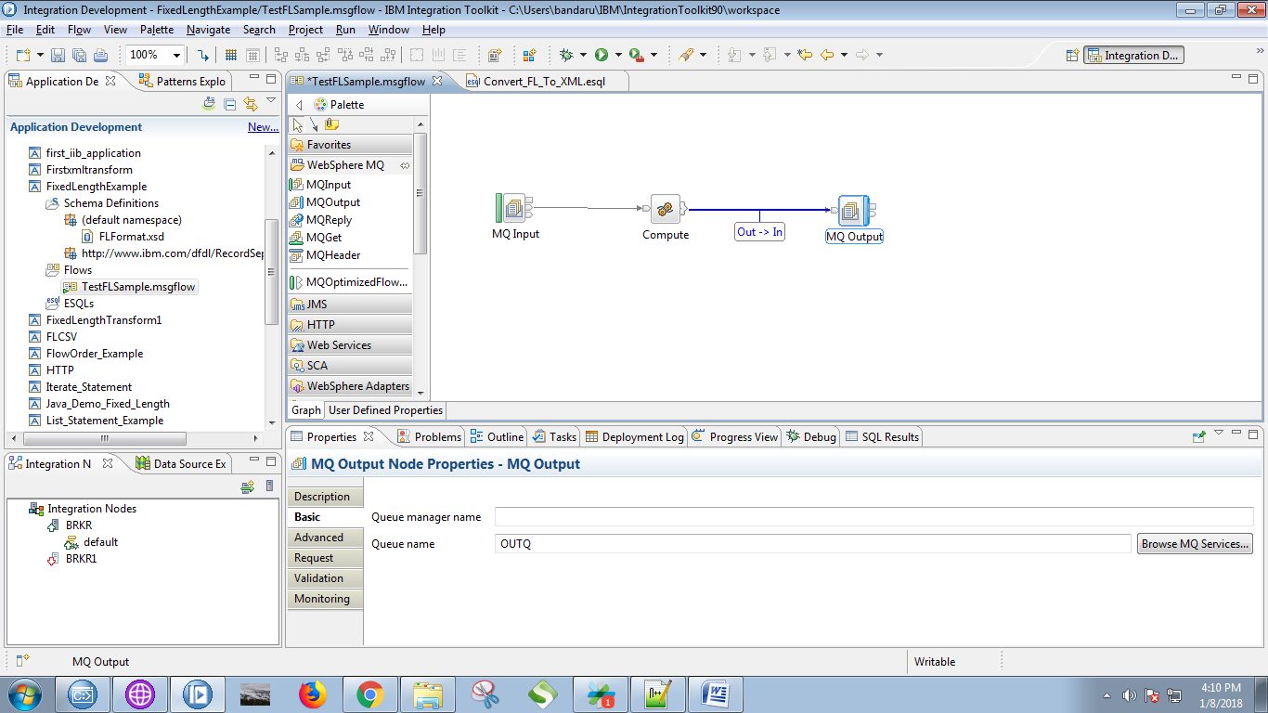

29. Copy the below code in the compute node.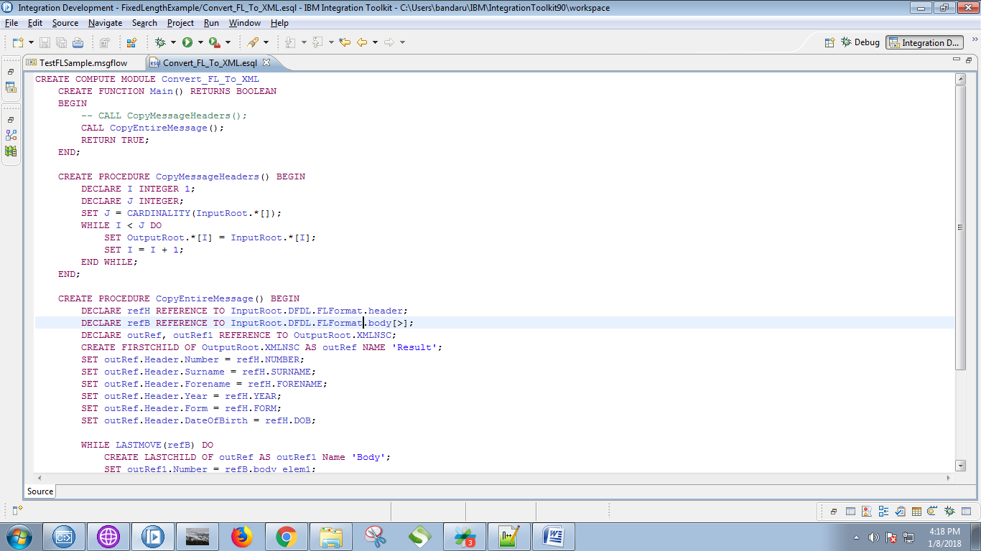

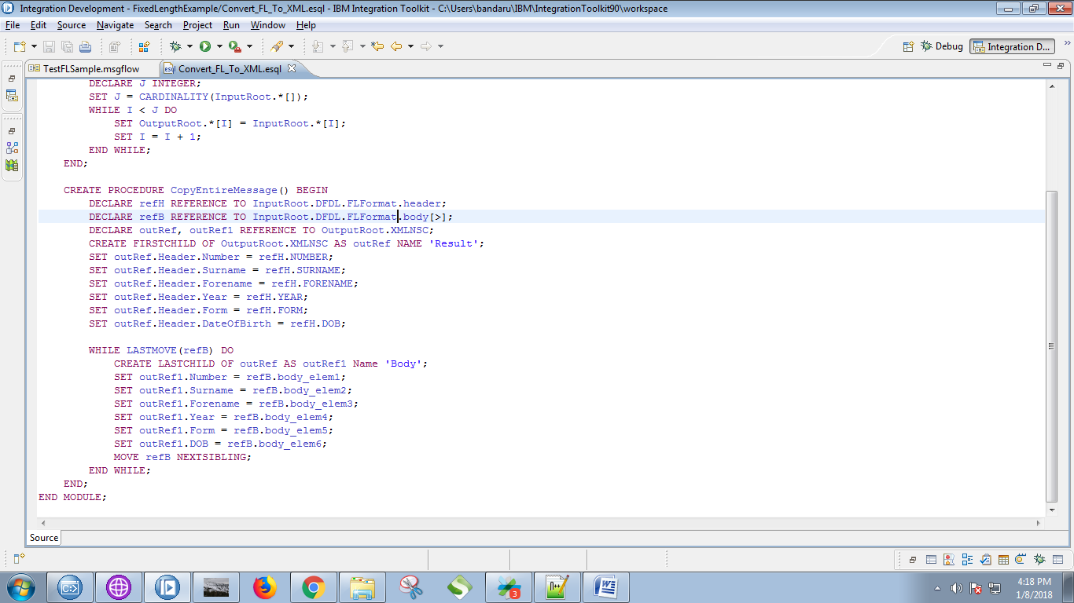

CREATE PROCEDURE CopyEntireMessage() BEGIN

DECLARE refH REFERENCE TO InputRoot.DFDL.FLFormat.header;

DECLARE refB REFERENCE TO InputRoot.DFDL.FLFormat.body[>];

DECLARE outRef, outRef1 REFERENCE TO OutputRoot.XMLNSC;

CREATE FIRSTCHILD OF OutputRoot.XMLNSC AS outRef NAME 'Result';

SET outRef.Header.Number = refH.NUMBER;

SET outRef.Header.Surname = refH.SURNAME;

SET outRef.Header.Forename = refH.FORENAME;

SET outRef.Header.Year = refH.YEAR;

SET outRef.Header.Form = refH.FORM;

SET outRef.Header.DateOfBirth = refH.DOB;

WHILE LASTMOVE(refB) DO

CREATE LASTCHILD OF outRef AS outRef1 Name 'Body';

SET outRef1.Number = refB.body_elem1;

SET outRef1.Surname = refB.body_elem2;

SET outRef1.Forename = refB.body_elem3;

SET outRef1.Year = refB.body_elem4;

SET outRef1.Form = refB.body_elem5;

SET outRef1.DOB = refB.body_elem6;

MOVE refB NEXTSIBLING;

END WHILE;

END;

30. Right click on application and select "Deploy" option.

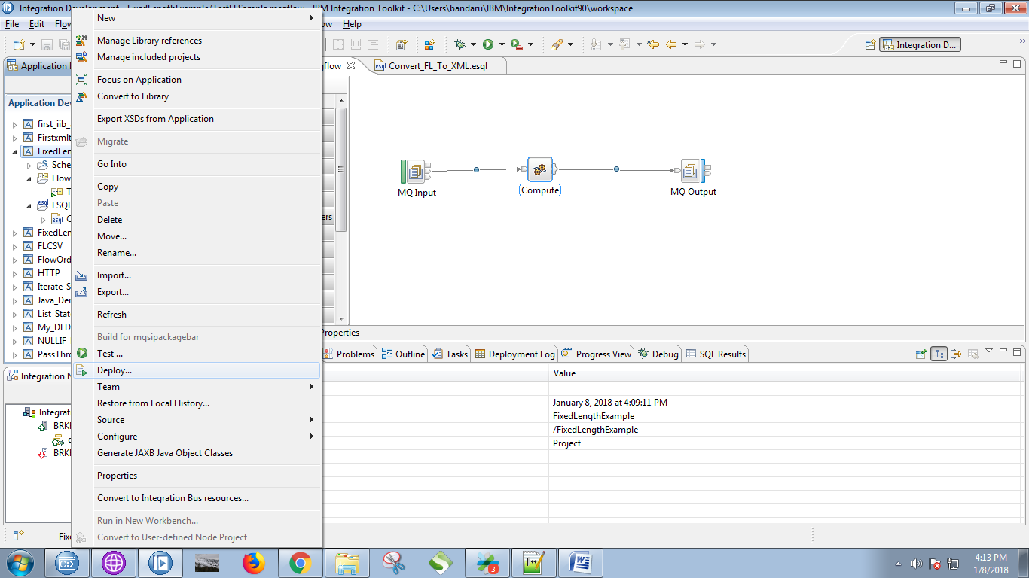

31. Select your running broker and execution group and click on "Finish" button.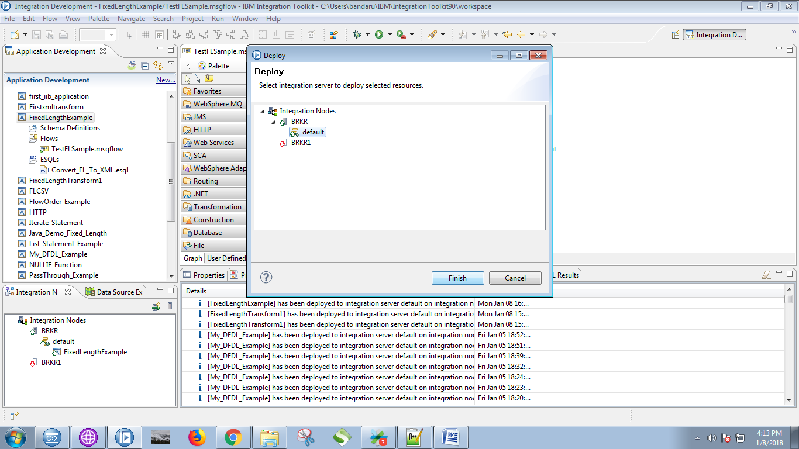

32. Open RFHUtil and select input queue and click on "Open File" and select your desired file.

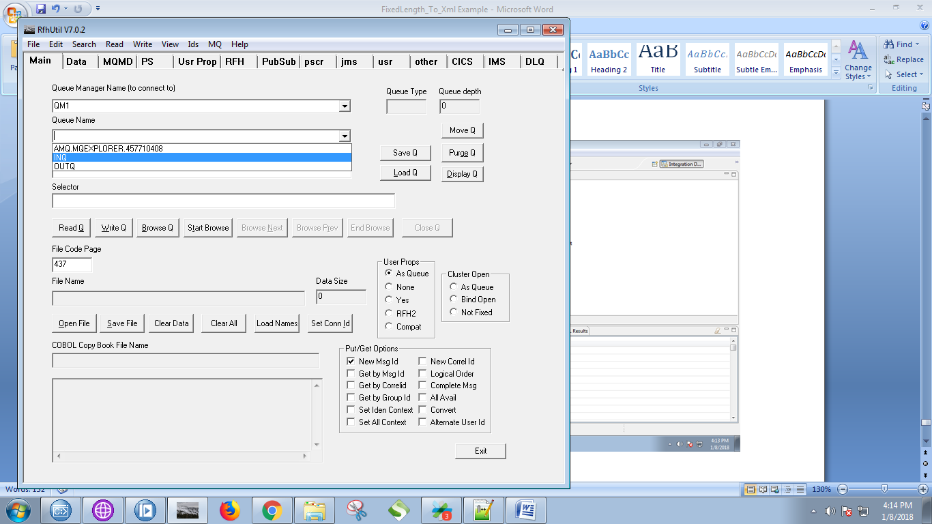

33. After selecting the file click on "Write Q".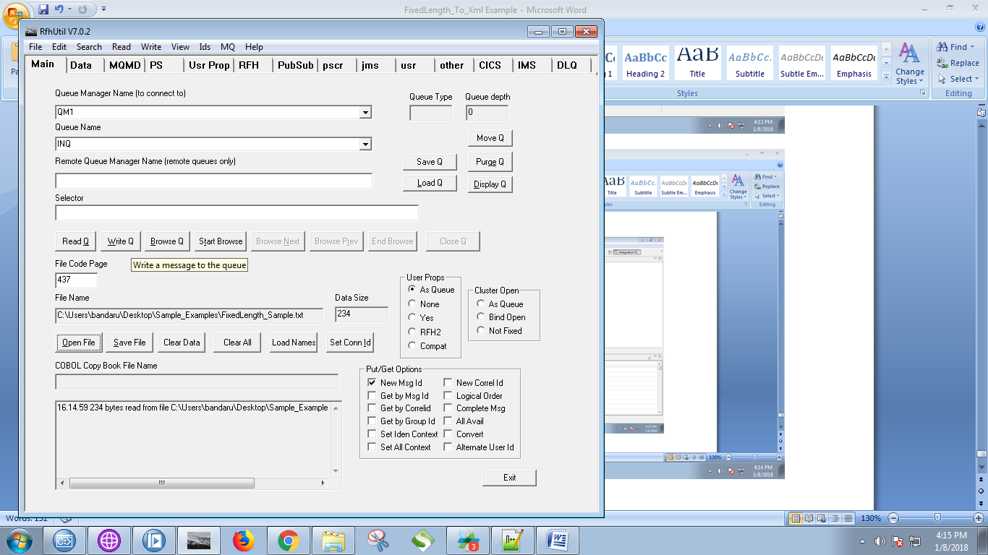

34. Here is my example file.

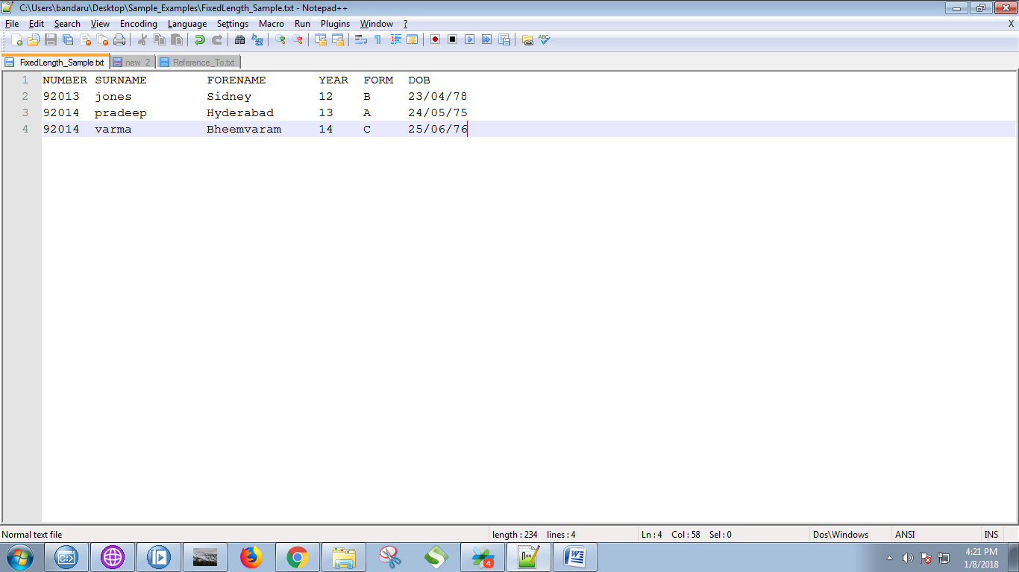

35. Output of the MQInput can be seen in debug mode.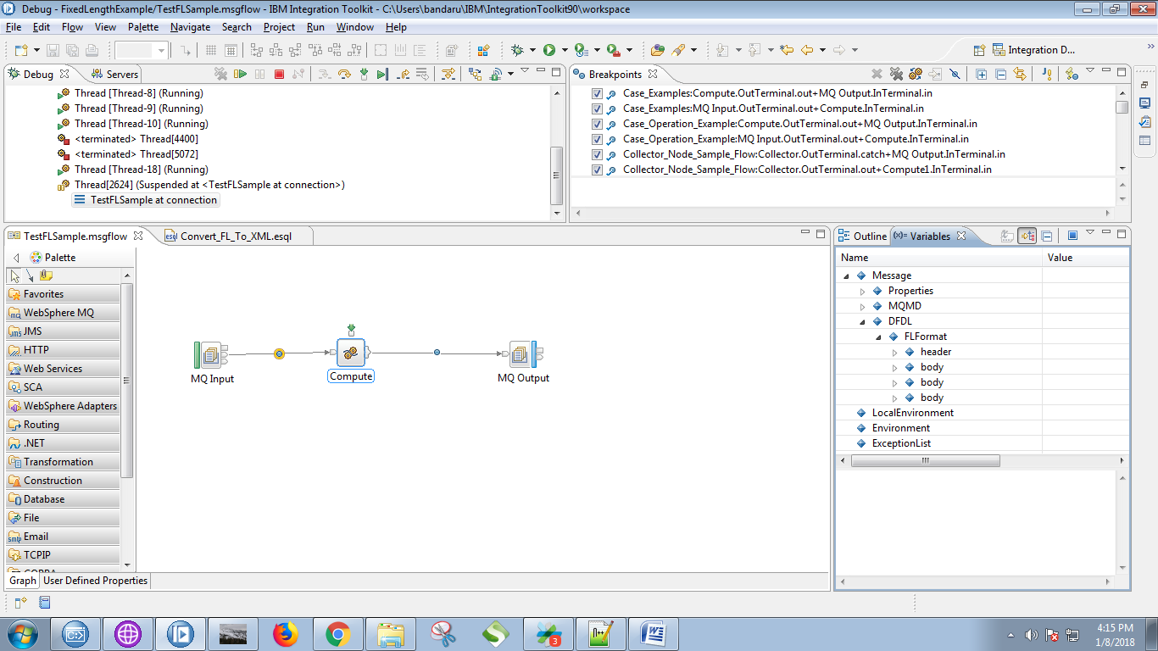

36. Output of the compute node will be seen in debug mode.

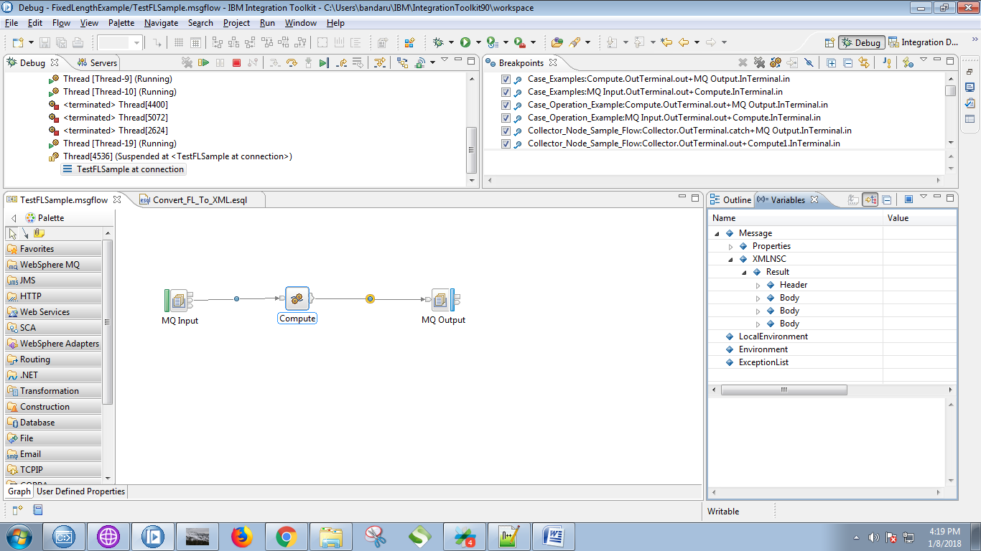

37. Select your output queuq in RFHUtil.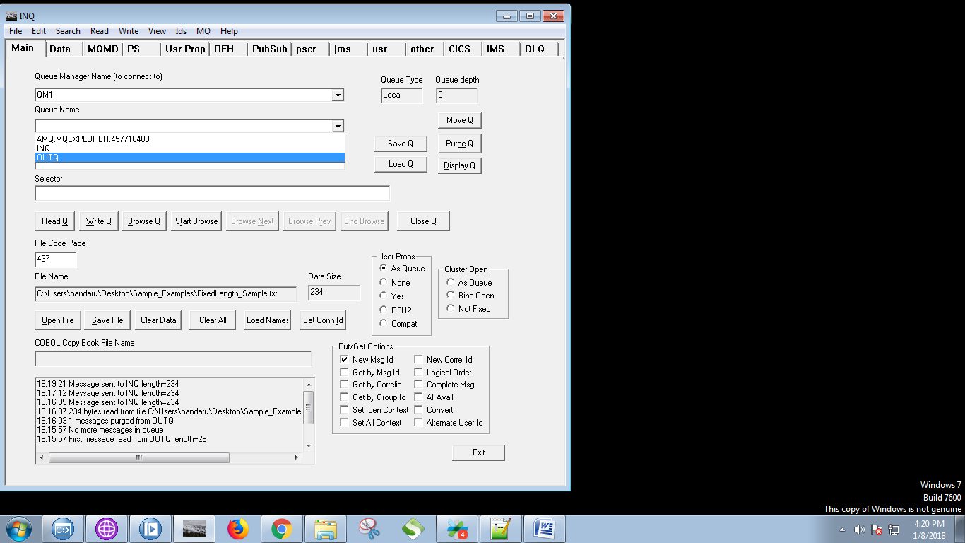

38. Click on "Browse Q".

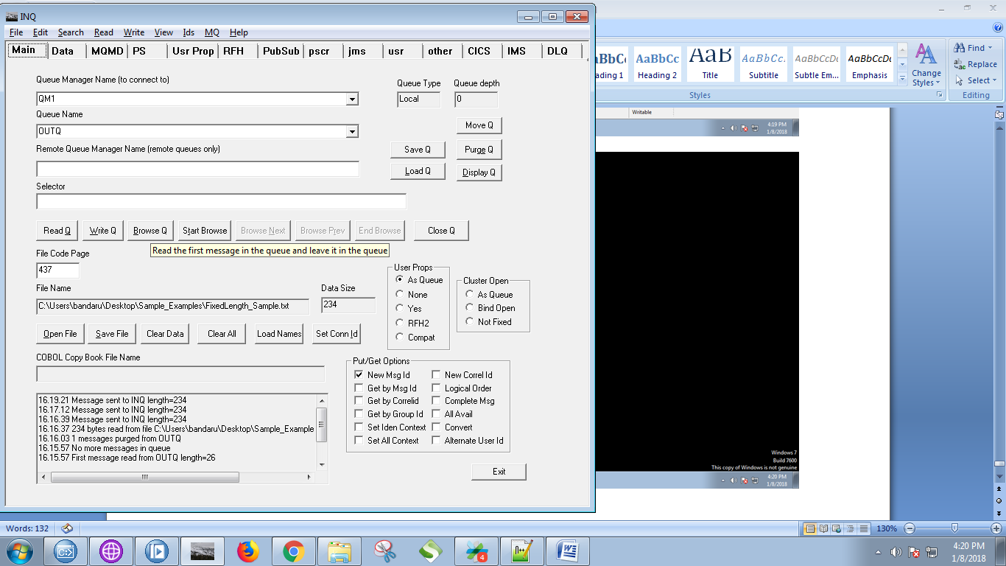

39. Your output will find in "Data" tab of the RFTUtill.